**Linux Assignment**

**1. Creating and Renaming Files/Directories**

**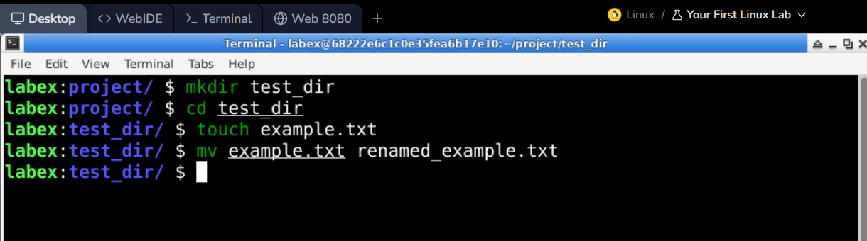  
Explanation:**

* mkdir – Used to create directories.
* cd – Used to enter the directory.
* touch – Used to create empty files.
* mv – Used to move or rename the files.

**2. Viewing File Contents**

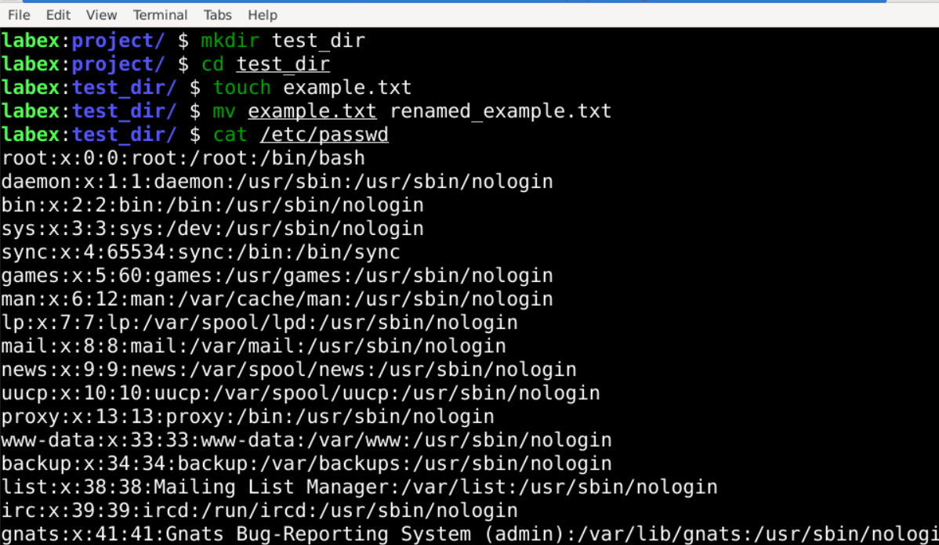

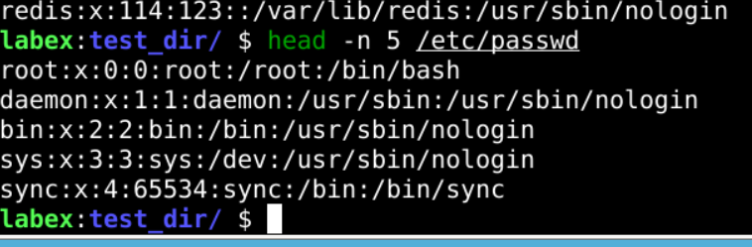

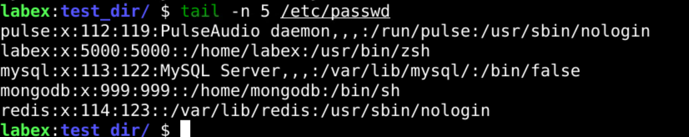

**Explanation:**

* /etc/passwd - stores user account info.
* cat – it displays the entire file.
* head - shows top n lines.
* tail - shows bottom n lines.

**3.Searching for Patterns**

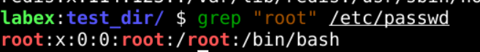

**Explanation:**

* grep - Searches for the pattern "root" in the file /etc/passwd.

**4. Zipping and Unzipping**

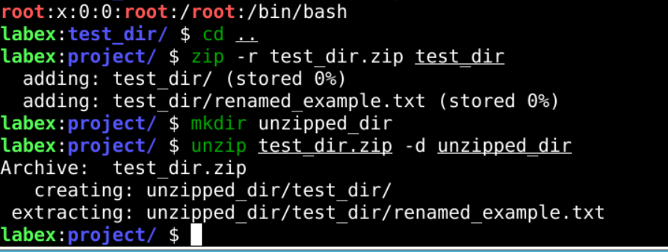

**Explanation:**

* zip -r - creates a zip archive.
* unzip - extracts the zip contents.
* -d - specifies the destination directory.

**5. Downloading Files**

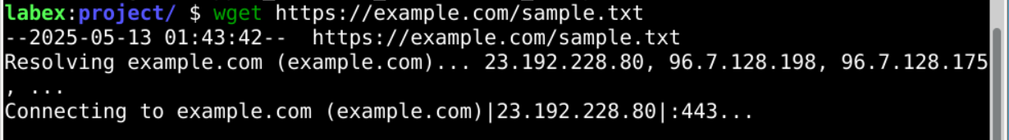

**Explanation:**

* wget - Used to download files from a URL.

**6. Changing Permissions**

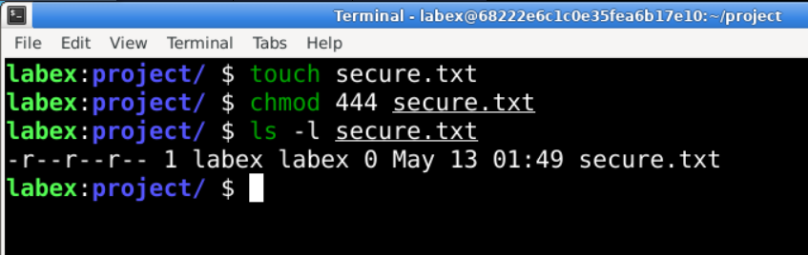

**Explanation:**

* chmod 444 - read-only for all.
* ls -l - shows permissions.

**7. Working with Environment Variables**

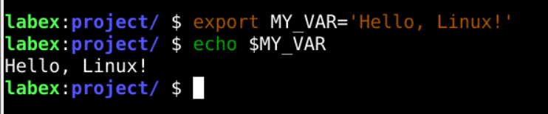

**Explanation:**

* export - sets the environment variables.
* echo - prints the value.